Budget Wise AI-Based Expense Forecasting Tool

1. Introduction
The Budget Wise AI-Based Expense Forecasting Tool is a smart tool that tracks user expenses, categorizes them, and forecasts future spending patterns using AI/ML models. It helps individuals and businesses manage budgets effectively, predict overspending, and provide actionable insights.

2. Project Statement
Many individuals struggle with managing their personal finances effectively, often finding it difficult to track spending, stick to a budget, and plan for future financial goals. The sheer volume of daily transactions can be overwhelming, making it hard to identify spending patterns or anticipate upcoming expenses. This lack of financial clarity can lead to stress, missed savings opportunities, and difficulty in achieving long-term financial stability. The 'Personal Budgeting & Expense Forecaster' project aims to address these challenges by developing an intuitive tool that helps individuals gain control over their finances. By leveraging time-series forecasting on historical transaction data (using simulated or real data), this tool empowers users to make informed financial decisions and maintain sustainable financial health.
3.System architecture
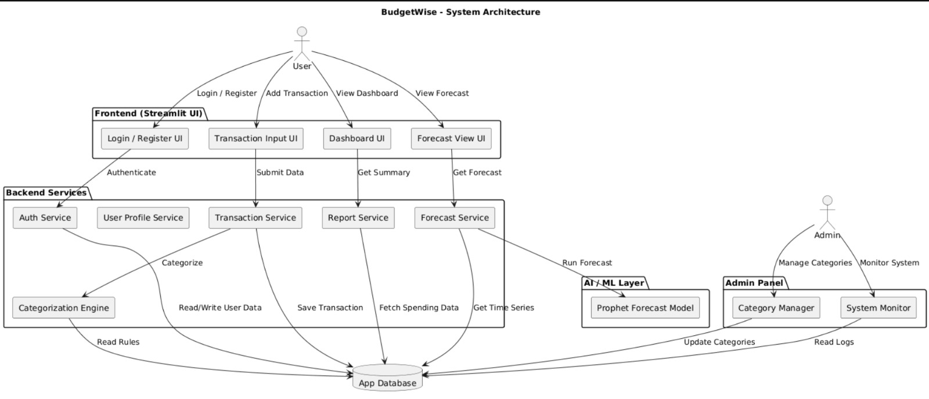

4.Functional Requirements
1.User Authentication
2.User Profile Management
3.Admin Management
4.Transaction Entry
5.Automatic Category Detection
6.Dashboard Overview
7.Spending Reports
8.Daily Financial Trend Visualization
9.Expense Forecasting
10.Forecast Export
11.Financial Goal Creation
12.Goal Progress Tracking
13.Database Storage

5.Non-Functional Requirements
1.Performance
2.Security
3.Usability & UI Simplicity
4.Reliability
5.Compatibility
6.Maintainability
7.Scalability
8.Data Integrity

Milestone 1
• User Registration: Implement a secure user registration system with standard email/password authentication.
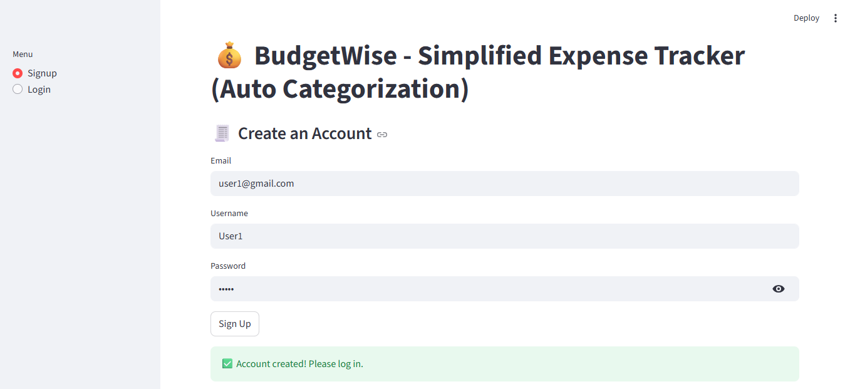
• Login System: Develop a robust login mechanism to authenticate users.
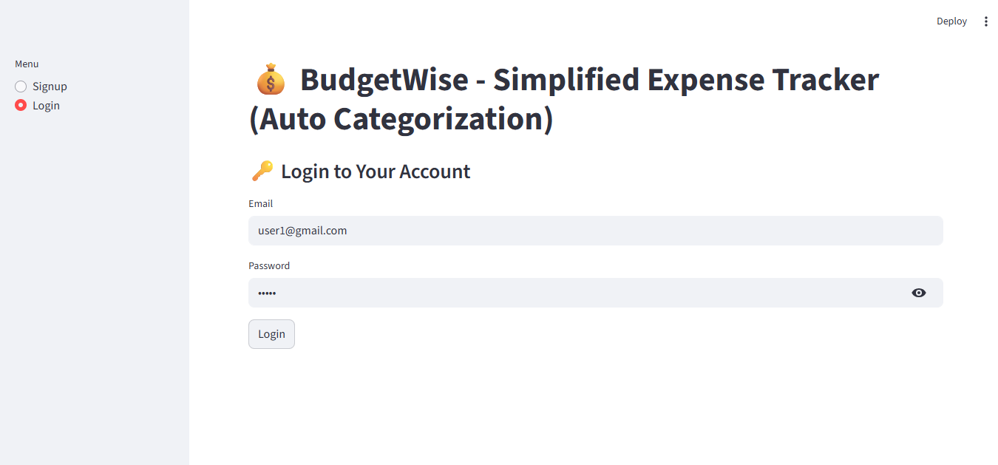

• Profile Management: Create user profiles for managing their financial data.
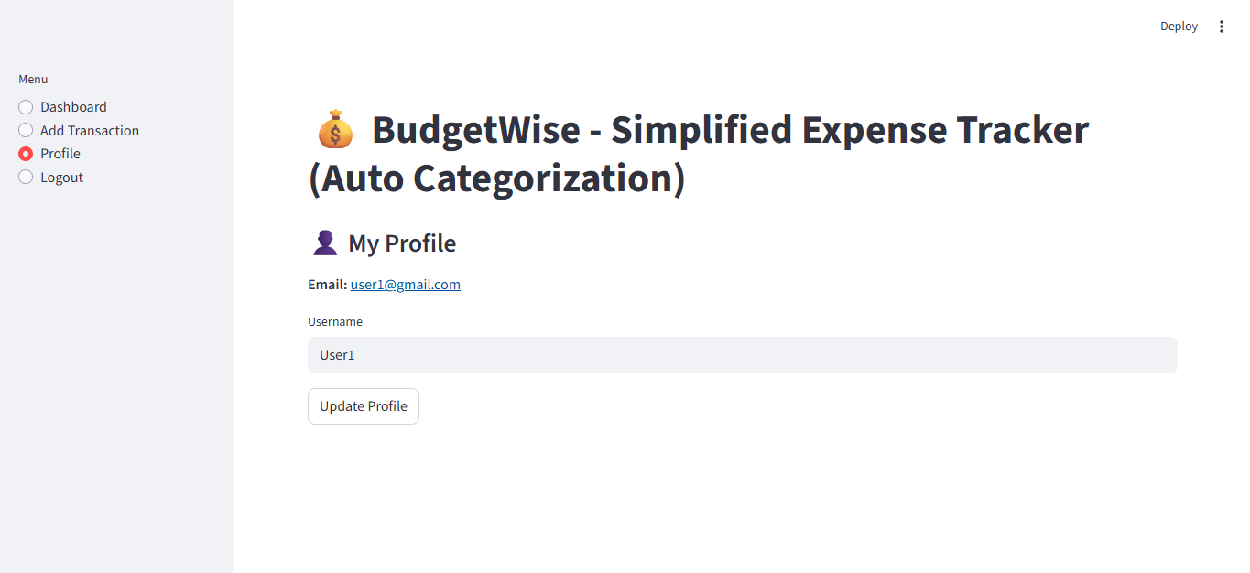
• Manual Transaction Input: Design a basic web interface (using Streamlit) allowing users to manually input individual dummy transactions (e.g., date, amount, description, type: income/expense).

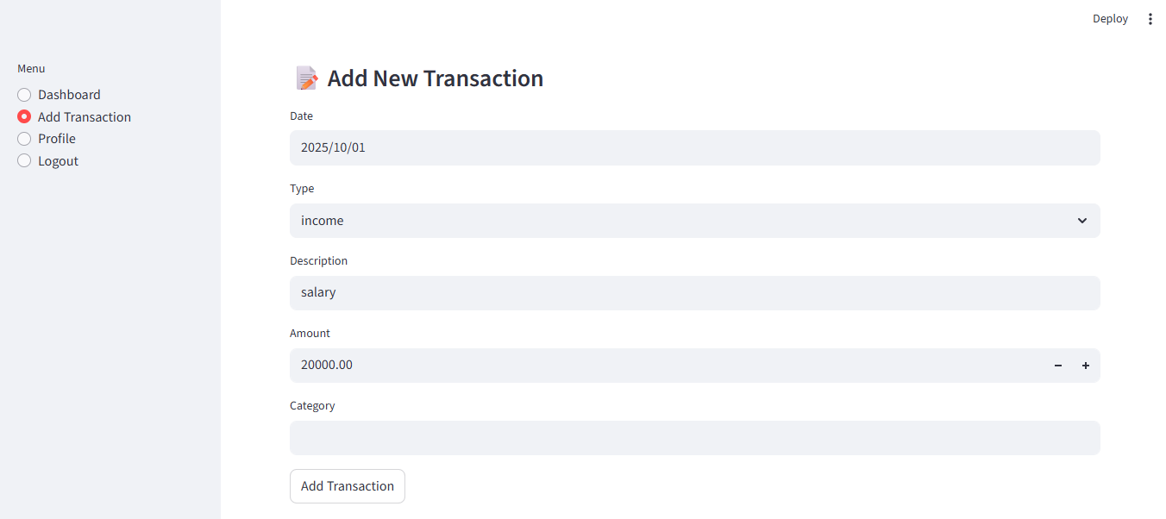

Milestone 2
• Automated Categorization: Implement a rule-based or simple NLP (keyword matching) system to automatically assign categories (e.g., 'Groceries', 'Rent', 'Transport') to transaction descriptions. Allow manual override.
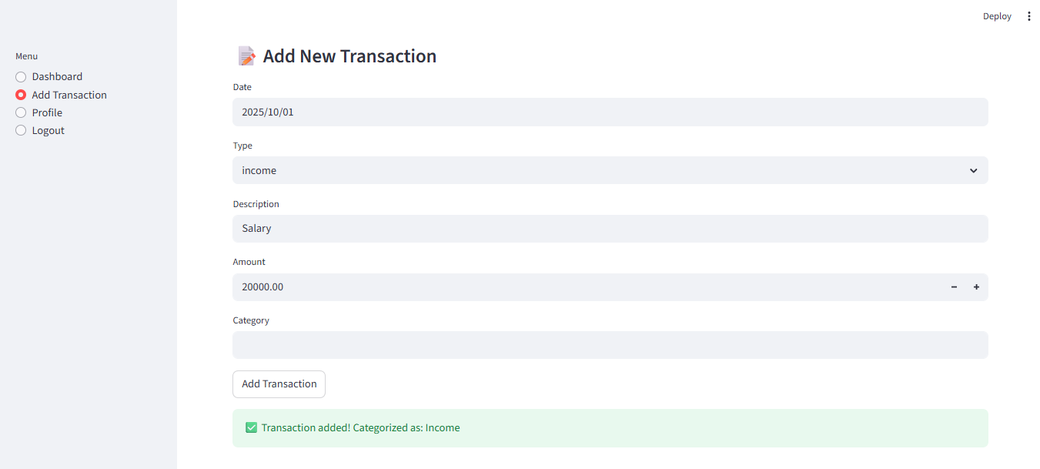
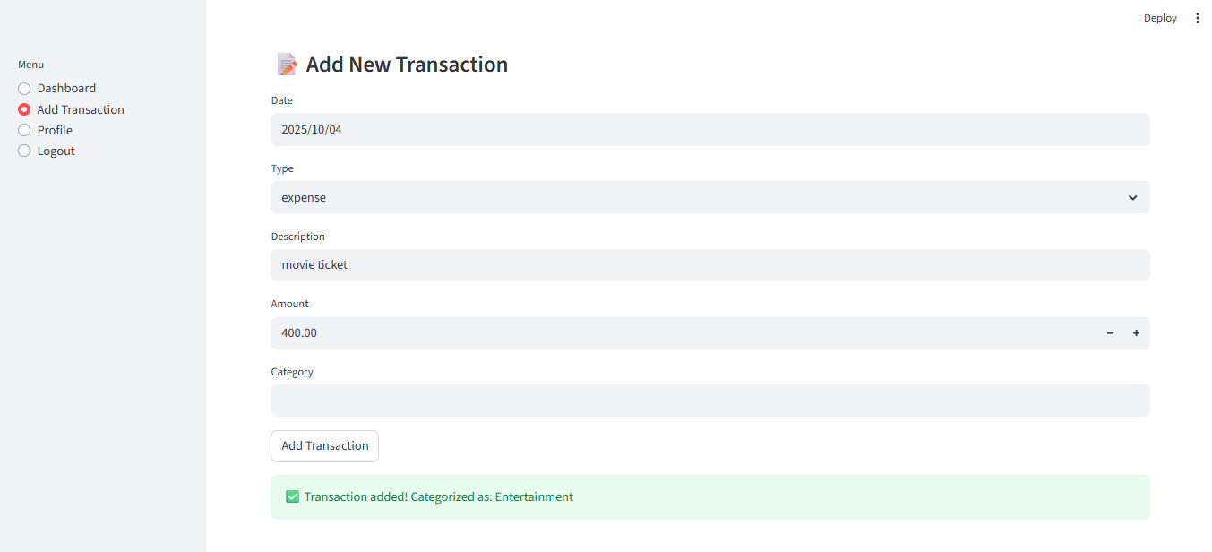

• Spending Summary Reports: Develop functionality to generate basic reports showing total spending per category, monthly spending summaries, and income vs. expense over a period using Pandas.
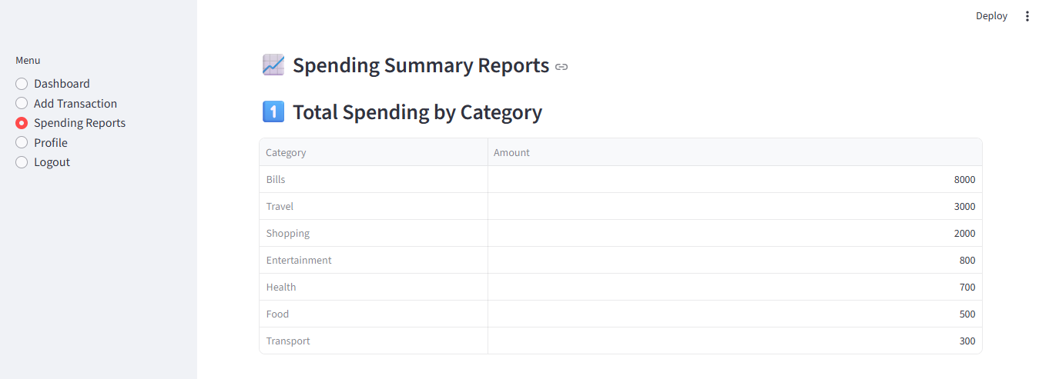
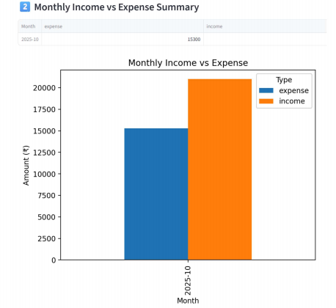
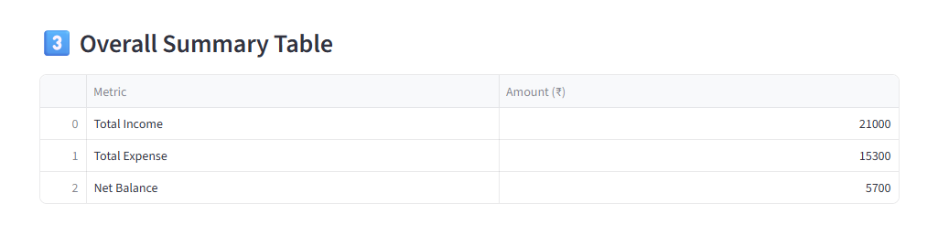
• Initial Dashboard View: Enhance the UI to display a summary of recent transactions and a basic breakdown of spending by category (e.g., a pie chart or bar chart using Matplotlib).
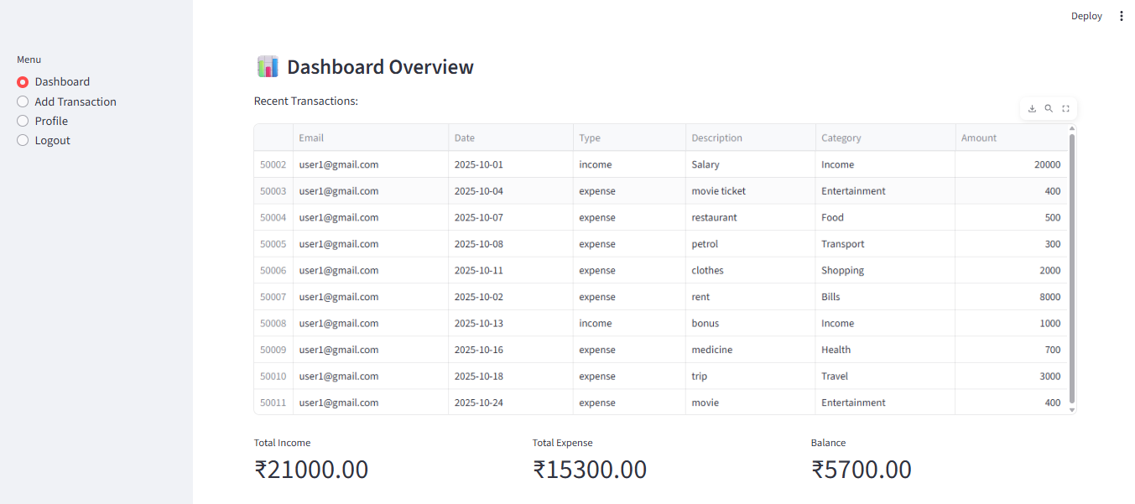

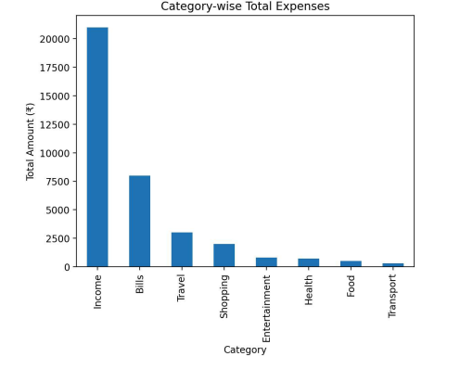
S
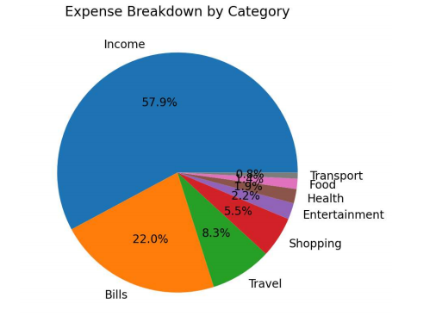

Milestone 3
- Historical Data Preparation: Prepare historical transaction data in the format required by the forecasting model (time series of aggregated daily/weekly/monthly expenses per category).

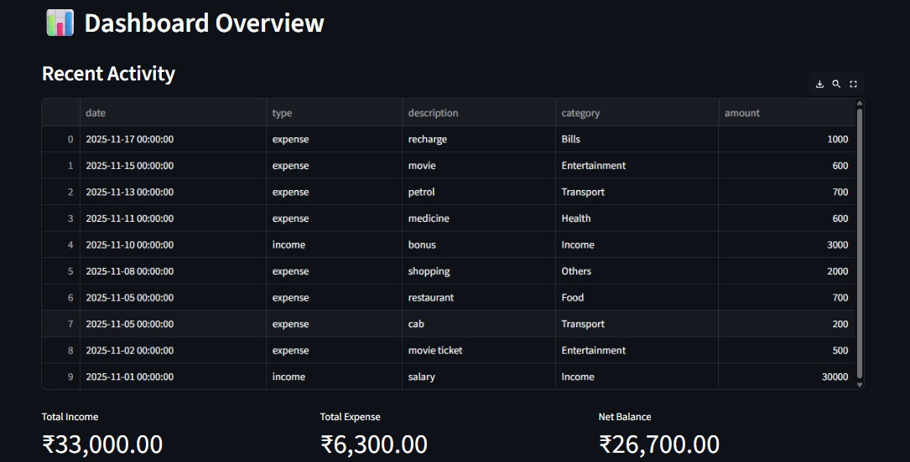

- Prophet Integration: Integrate Prophet (Meta's forecasting library) to generate future expense forecasts for different categories or overall spending.

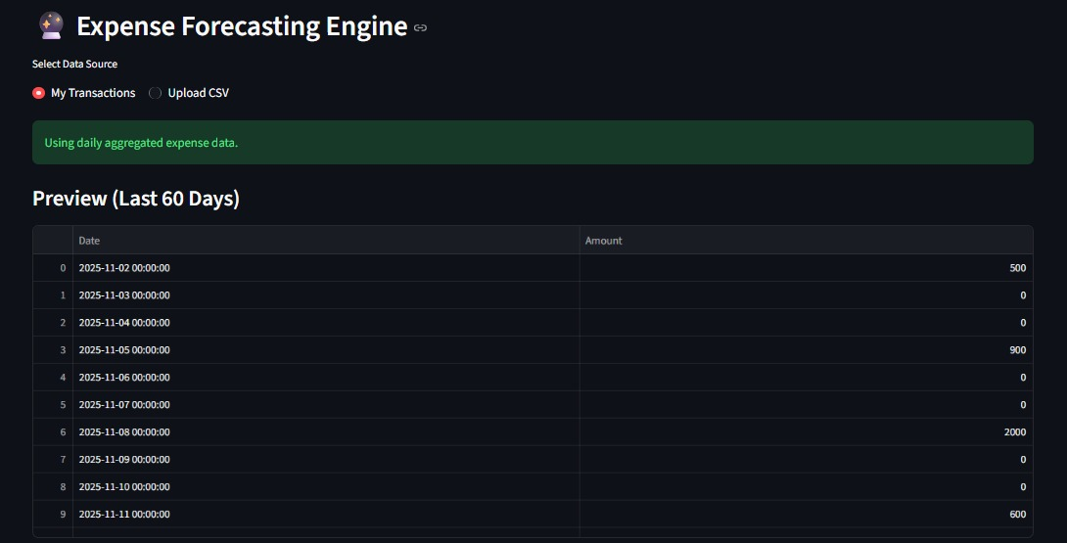

- Financial Goal Setting: Allow users to define financial goals.

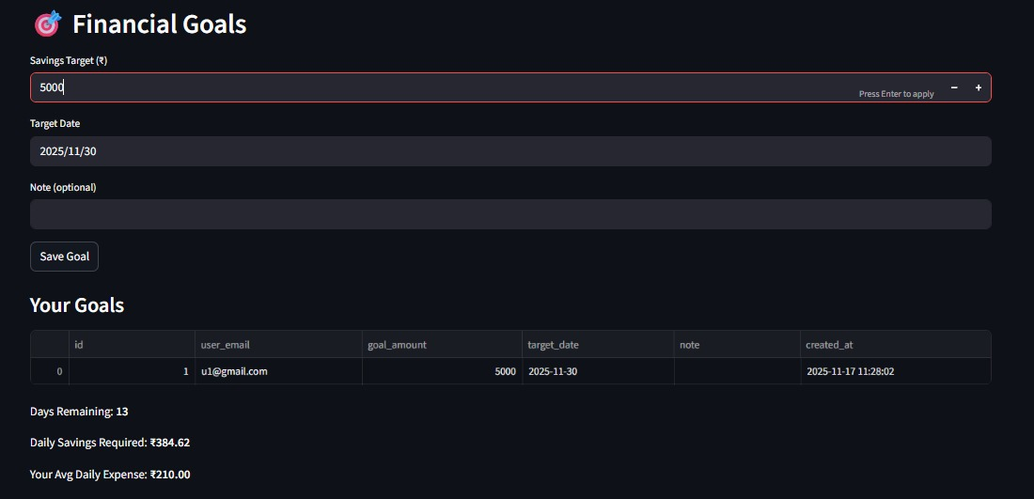

- Forecast Visualization: Update the dashboard to display the forecasted expenses alongside actual historical data. Show projected savings based on forecasts.

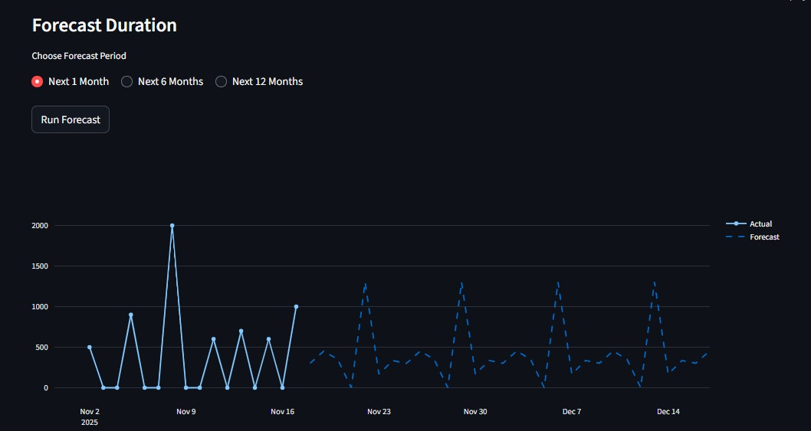

Milestone 4
- Interactive Financial Dashboard: Develop a comprehensive, interactive financial dashboard that includes detailed spending breakdown by custom periods. Income vs. Expense trends.
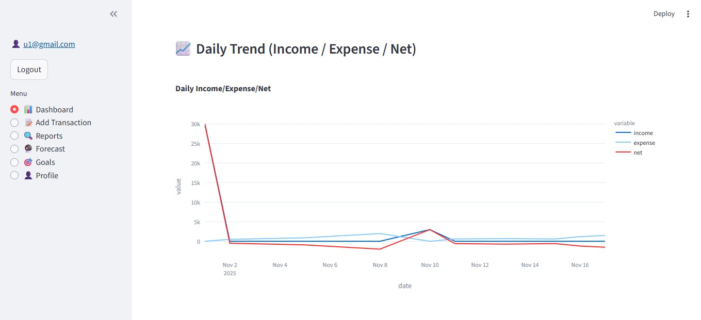
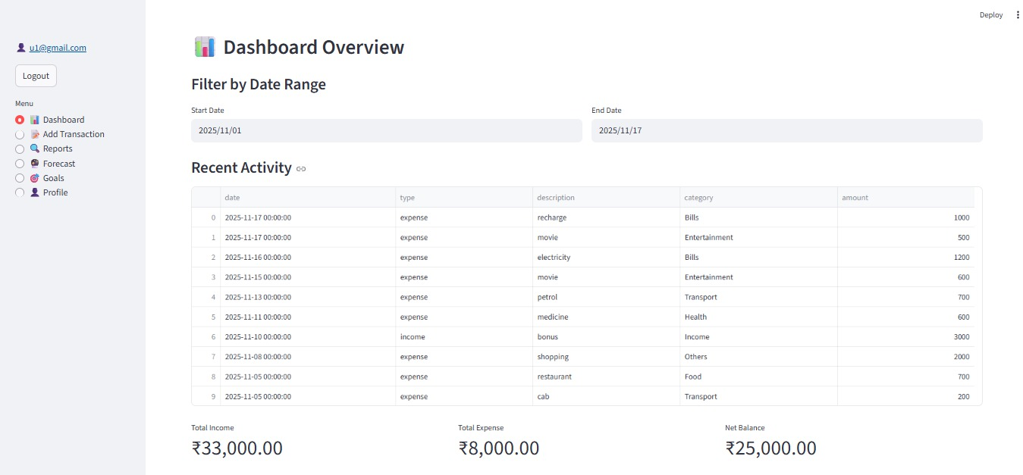

Admin Dashboard: Developing a basic admin interface for:
Managing predefined transaction categories and rules.
Monitoring system usage and data consistency.
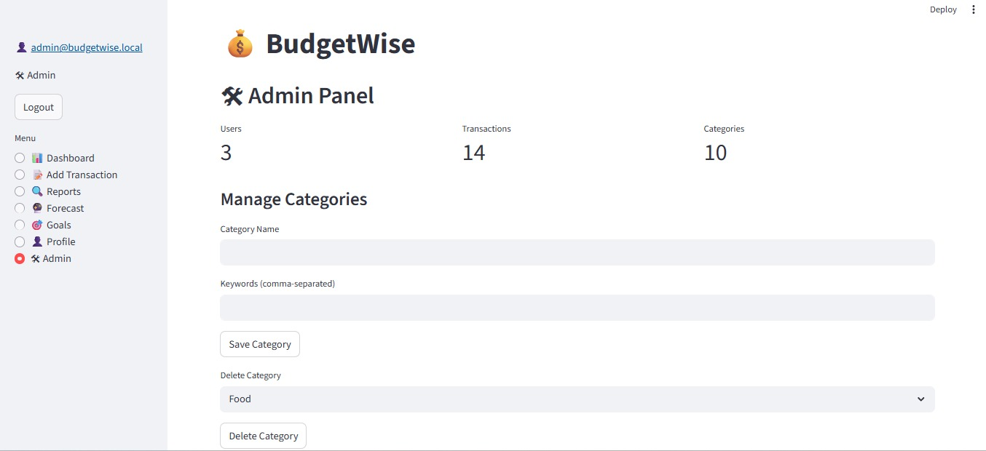
Conclusion
The BudgetWise system provides a simple yet powerful solution for personal financial management by allowing users to securely record transactions, analyze spending patterns, set financial goals, and generate future expense forecasts. Through interactive dashboards, automated category detection, goal-tracking features, and reliable database storage, the application helps users understand their financial habits and make informed decisions. With its user-friendly interface and essential admin controls, BudgetWise achieves its objective of offering an organized, efficient, and practical platform for managing day-to-day finances.

